🔹 Auto Scaling (AWS)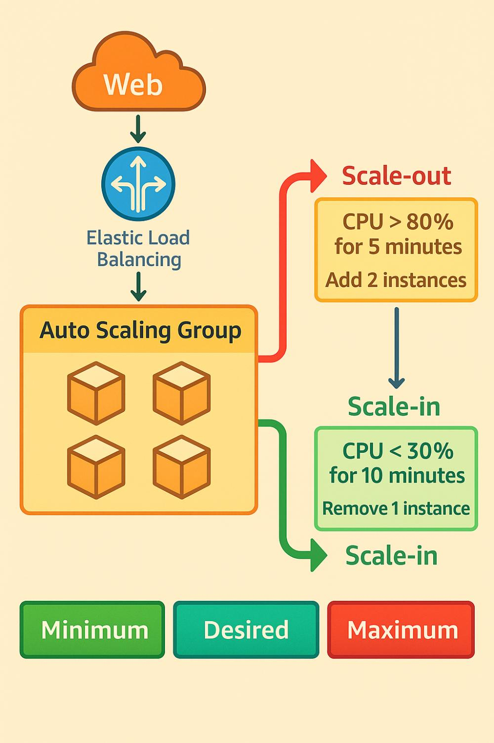
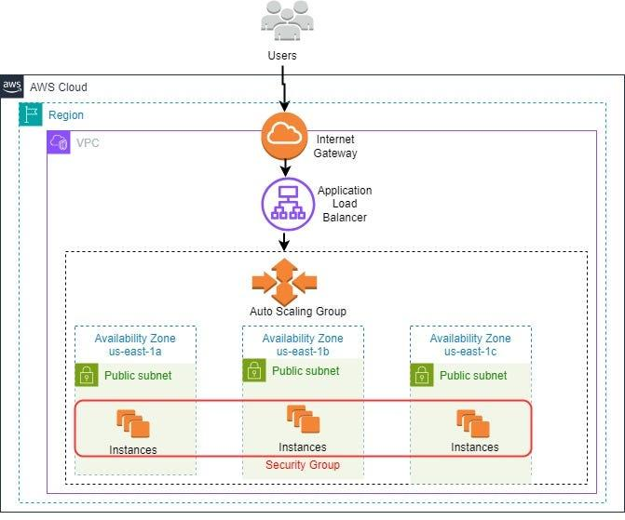
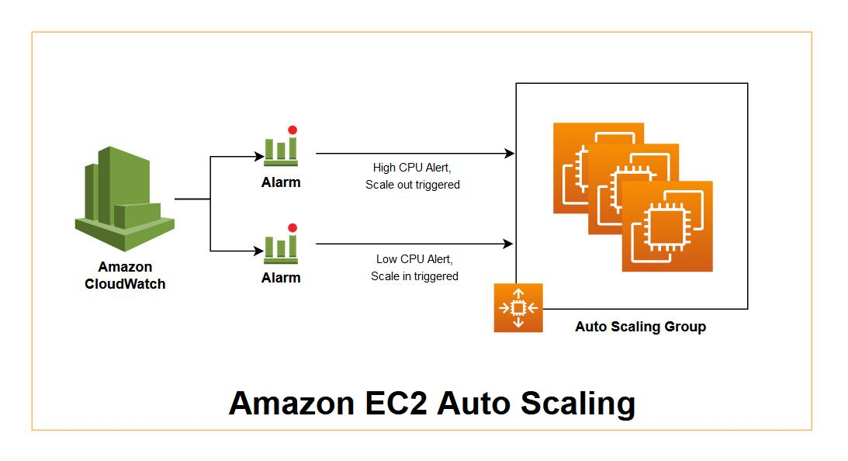
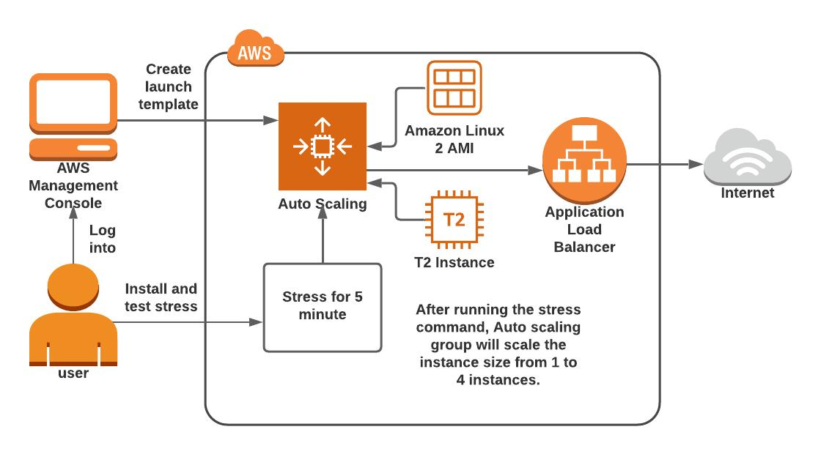
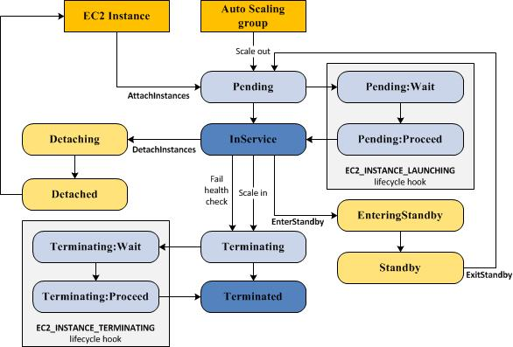
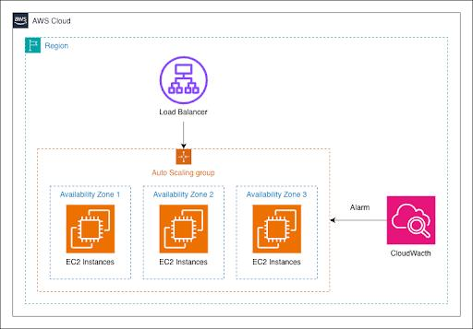
✅ What is Auto Scaling?
Auto Scaling automatically adds or removes EC2 instances based on load.
👉 Example:
- High traffic → instances increase
- Low traffic → instances decrease
✅ Why use Auto Scaling?
- High availability
- Cost optimization 💰
- Fault tolerance
- Automatic scaling (no manual work)

🔹 Types of Auto Scaling
1️⃣ Dynamic Scaling
👉 Automatically adjusts based on metrics (CPU, traffic)
- Example:
If CPU > 70% → add instance
If CPU < 30% → remove instance

2️⃣ Scheduled Scaling
👉 Runs at fixed time
- Example:
  - Morning 9 AM → scale up
  - Night 10 PM → scale down

3️⃣ Predictive Scaling
👉 Uses ML to predict traffic
- Example:
  - Every Sunday high traffic → auto increase before load

🔹 Launch Template
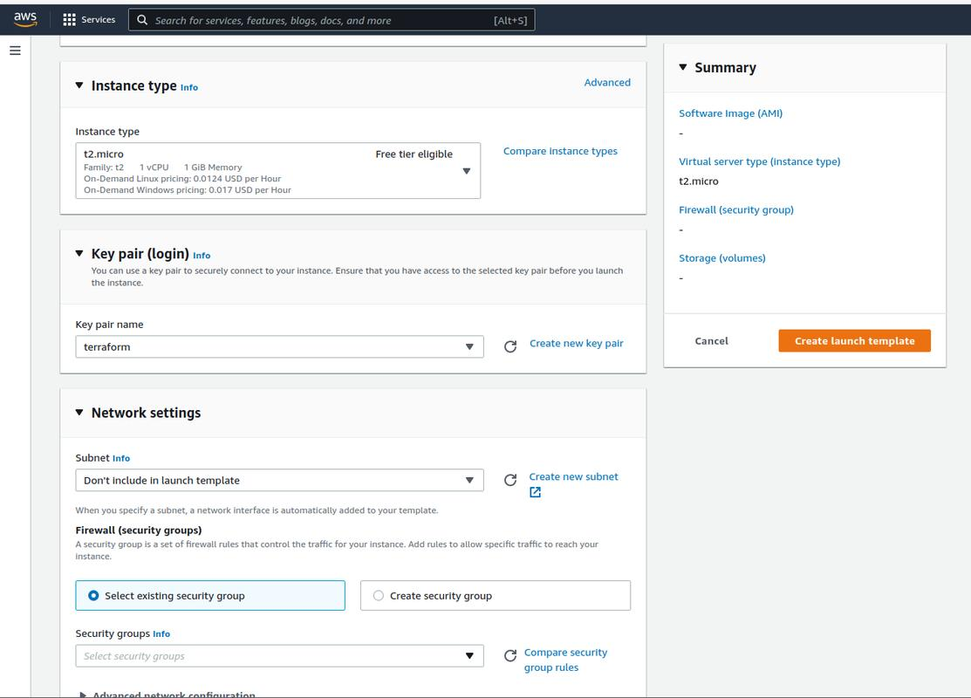
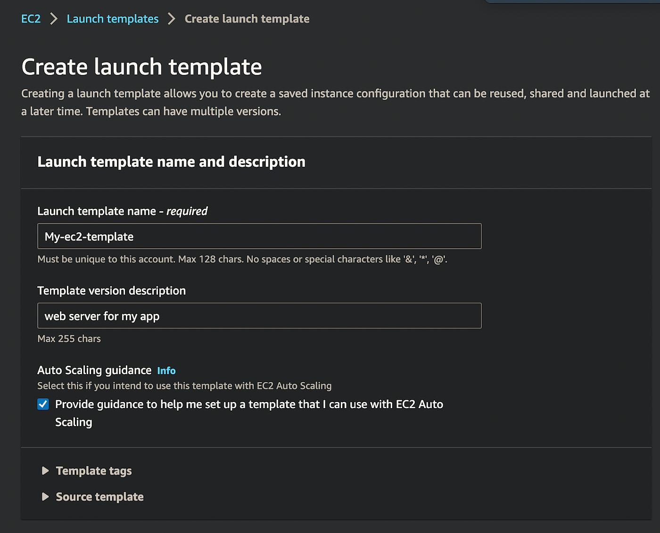
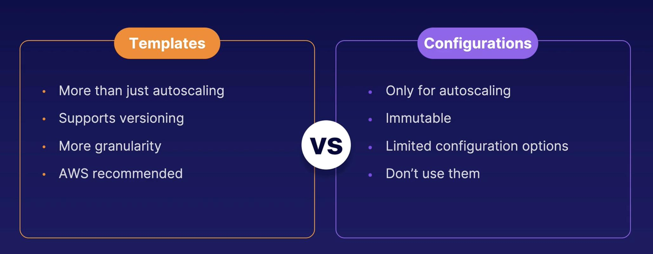
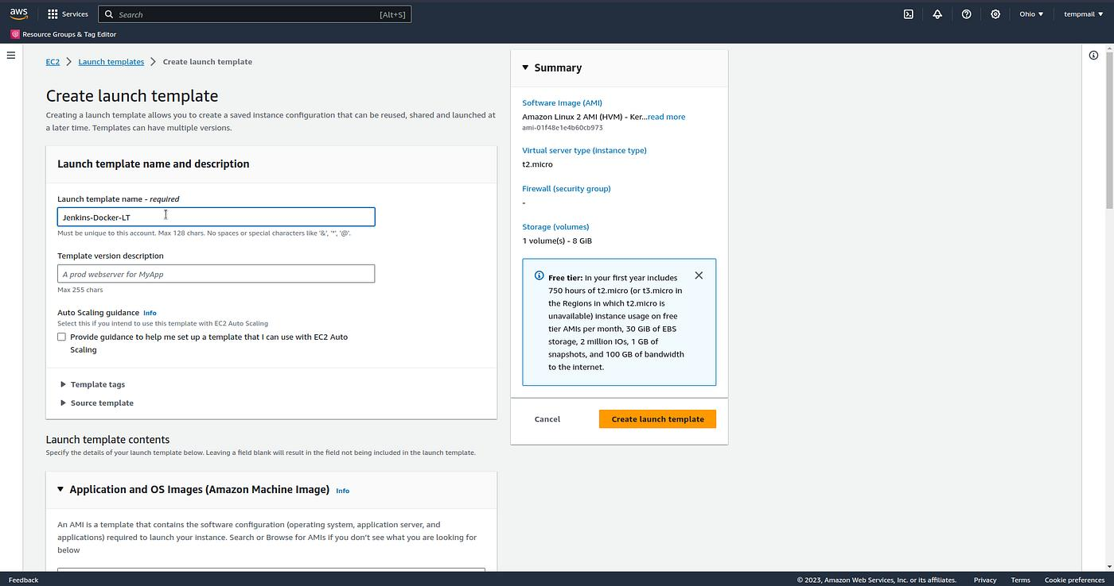
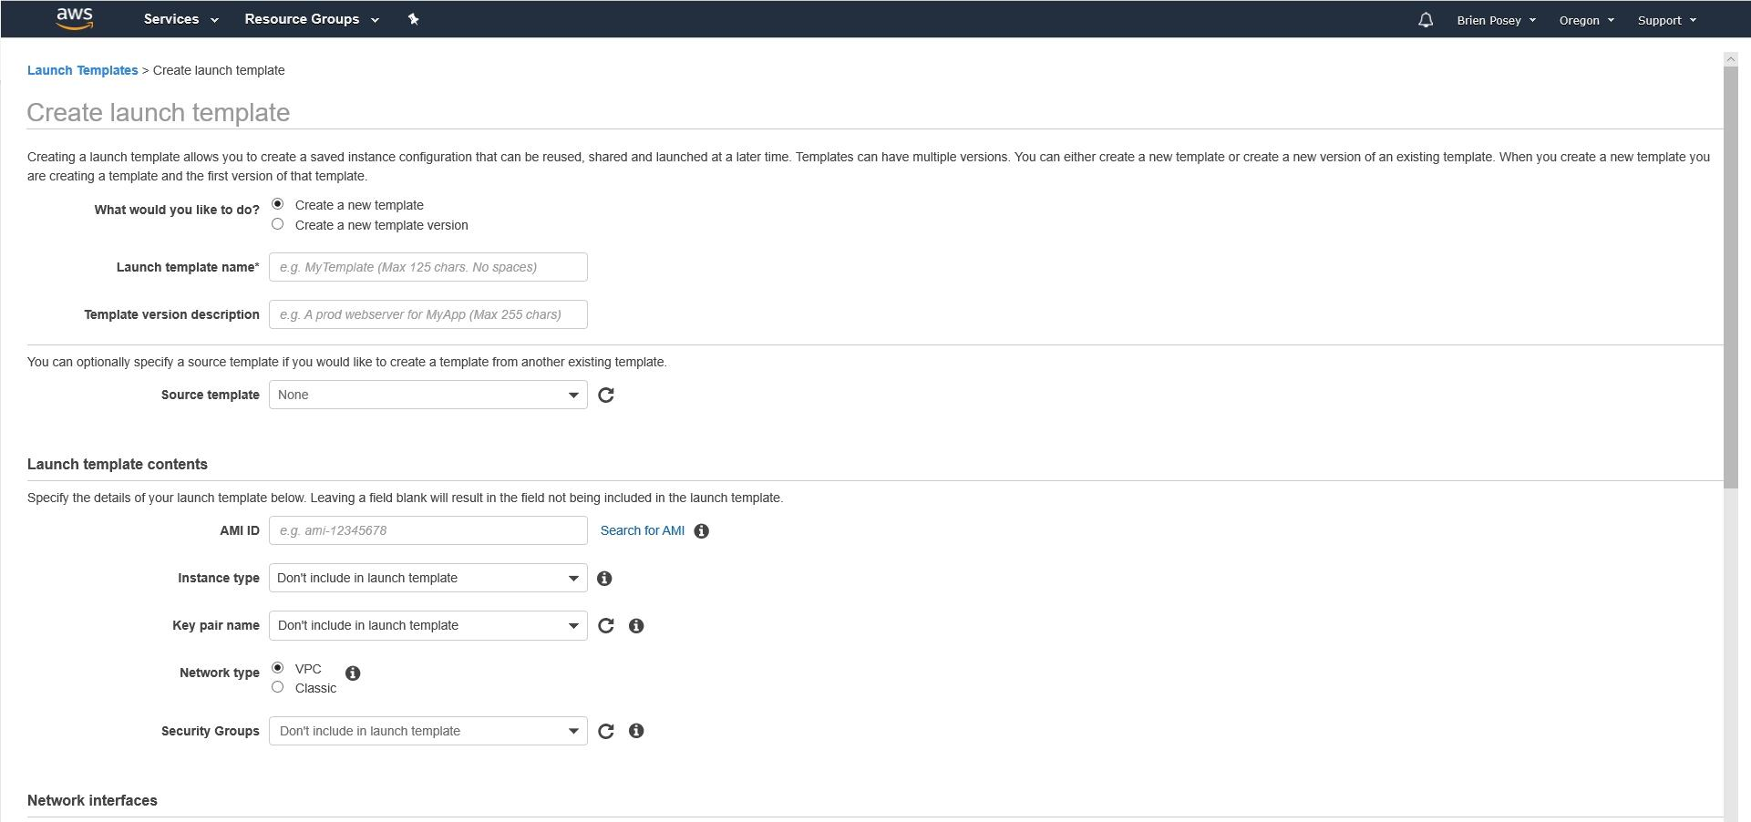
✅ What is Launch Template?
It is a blueprint for EC2 instances.
👉 It contains:
- AMI (Ubuntu / Amazon Linux)
- Instance type (t2.micro)
- Key pair
- Security group
- Storage

🔧 Steps to Create Launch Template
- Go to EC2 → Launch Templates
- Click Create launch template
- Enter:
  - Name: my-template
  - AMI: Ubuntu
  - Instance type: t2.micro
  - Key pair: select
  - Security group: allow SSH (22)
- Click Create

🔹 Auto Scaling Group (Demo)
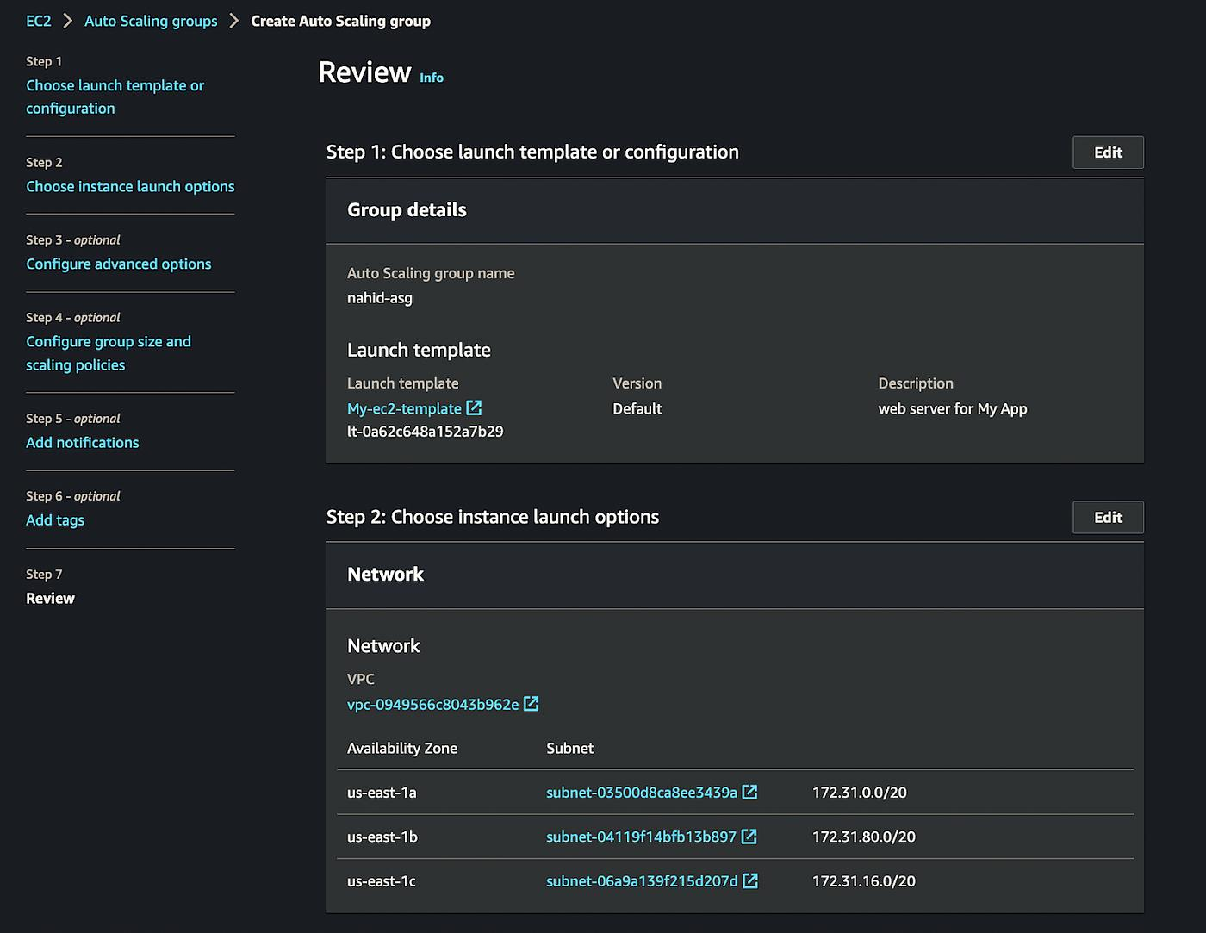
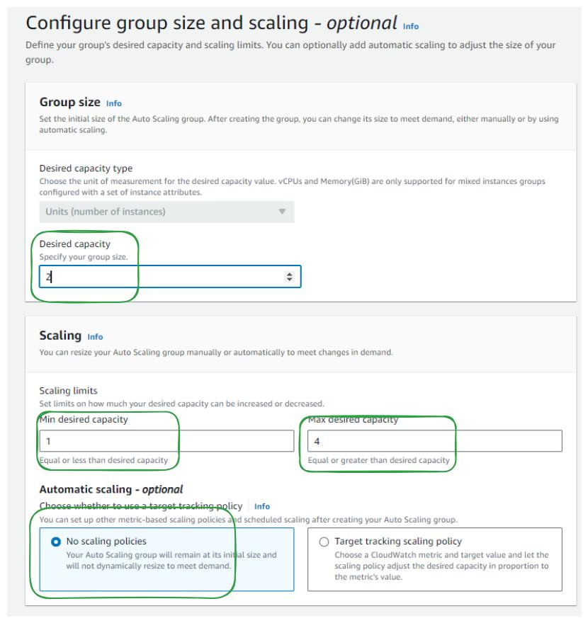
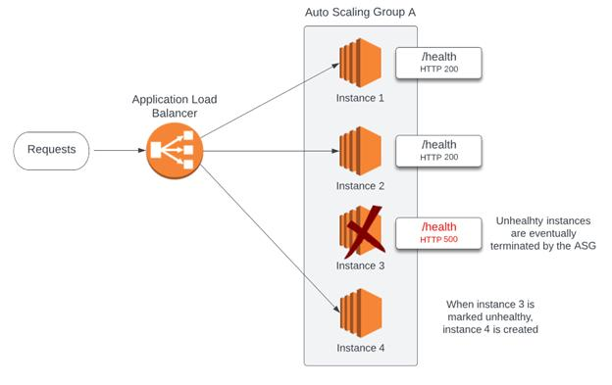
✅ What is Auto Scaling Group?
Group of EC2 instances managed automatically.
👉 It ensures:
- Minimum instances always running
- Replace unhealthy instances
- Scale up/down automatically

🔧 Steps to Create Auto Scaling Group
Step 1: Go to
👉 EC2 → Auto Scaling Groups → Create
Step 2: Select Launch Template
- Choose my-template
Step 3: Configure Group
- Name: my-asg
- VPC: select
- Subnets: select 2 (recommended)
Step 4: Set Capacity
- Desired: 2
- Min: 1
- Max: 4
Step 5: Attach Load Balancer (optional but best)
- Select ALB
Step 6: Add Scaling Policy
- Target tracking:
  - CPU = 50%
Step 7: Create ASG ✅

🔥 Real Demo Flow (Explain to Students)
👉 You can show this live:
- Create Launch Template
- Create ASG (min=1, max=3)
- Put CPU policy = 50%
- Connect to instance → run stress:
- sudo apt update
- sudo apt install stress -y
- stress --cpu 2
- Watch:
  - New instance automatically created 🚀

🧠 Interview Questions
- What is Auto Scaling?
- Difference between Launch Template & Launch Configuration?
- What is desired/min/max capacity?
- What happens if instance fails?
- What is health check in ASG?

